Registered charity number: 1175204

General Date Protection Regulations (GDPR) Policy
This is Veterans Outdoors (VO) policy to be followed by all staff and volunteers
Author | Operations Manager
Date approved by SMT | 30 Mar 22
Next Review Date | Jun 23

General Data Protection Regulations (GDPR) Policy

Purpose

This policy sets out why Veterans Outdoors (VO) has a GDPR Policy and the context of how it manages its data.

Who this policy applies to

All VO staff. For the purpose of this policy, the term ‘staff’ applies to all paid employees, volunteers, the Board of Trustees, Ambassadors, Mentors, Beneficiaries, Trainer, Land-based businesses and any other individual/organisation with an affiliation to VO.

Why we have this policy

Under the EU General Data Protection Regulations (GDPR) VO is committed to processing data in accordance with its responsibilities under the GDPR.

Data protection principles

- Article 5 of the GDPR requires that personal data shall be:

- Processed lawfully, fairly and in a transparent manner in relation to individuals
- Collected for specified, explicit and legitimate purposes and not further processed in a manner that is incompatible with those purposes; further processing for archiving purposes in the public interest, scientific or historical research or statistical purposes shall not be considered incompatible with the initial purposes
- Adequate, relevant and limited to what is necessary in relation to the purposes shall not be considered to be incompatible with the initial purposes
- Accurate and, where necessary, kept up to date; every reasonable step must be taken to ensure that personal data that is inaccurate, having regard to the purposes for which they are processed, is erased or rectified without delay
- Kept in a form which permits identification of data subjects for no longer than is necessary for the purposes for which personal data are processed; personal data may be stored for longer periods insofar as the personal data will be processed solely for archiving purposes in the public interest, scientific or historical research purposes or statistical purposes subject to implementation of the appropriate technical and organisational measures required by the GDPR in order to safeguard the rights and freedoms of individuals
- Processed in a manner that ensures appropriate security of the personal data, including protection against unauthorised or unlawful processing and against accidental loss, destruction or damage using appropriate technical or organisational measures

General provisions

- All VO staff are to be aware that:

- This policy applies to all personal date processed by VO
- The Responsible Person shall take responsibility for the charity’s ongoing compliance with this policy
- This policy shall be reviewed annually
- VO shall register with the Information Commissioner’s Office (ICO) as an organisation that processes personal information

Lawful, fair and transparent processing

- All VO staff are:

- To ensure its operating of data is lawful, fair and transparent. VO shall maintain a Register of Systems
- Aware that the Register of Systems shall be reviewed at least annually
- Aware that individuals have the right to access their personal data and any such requests made to VO shall be dealt with in a timely manner

Lawful Purposes

- All VO staff are to be aware that:

- All data processed by VO must be done on one of the following lawful bases: consent, contract, legal obligation, vital interests, public task or legitimate interests
- VO shall note the appropriate lawful basis in the Register of Systems
- Where consent is relied upon as a lawful basis for processing data, evidence of opt-in consent shall be kept with the personal data
- Where communications are sent to individuals based on their consent, the option for the individual to revoke their consent should be clearly available and systems should be in place to ensure such revocation is reflected in the TVFAF Register of Systems

Data minimisation

- VO will:

- Ensure that personal data is adequate, relevant and limited to what is necessary in relation to the purposes for which it is processed

Accuracy

- VO will:
- Take reasonable steps to ensure personal data is accurate
- Where necessary, for the lawful basis on which data is processed, shall put in place steps to ensure that personal data is kept up to date

Archiving

- VO will ensure that:
- Personal data is kept for no longer than necessary and will put in place an archiving policy for each area in which personal data is processed and review this process annually
- The archiving policy shall consider what data should/must be retained, for how long, and why

Security

- VO will:
- Ensure that personal data is stored securely using modern software that is kept up to date
- Ensure that access to personal data shall be limited to personnel who need access and appropriate security should be in place to avoid unauthorised sharing of information
- Ensure that when personal data is deleted, it is done safely and such that it is irrecoverable
- Ensure that appropriate backup and disaster recovery solutions shall be in place

Data Breach

- In the event of a breach of security leading to the accidental or unlawful
destruction, loss, alteration, unauthorised disclosure of, or access to, personal data, the Board of Trustees shall promptly assess the risk to people’s rights and freedoms and if appropriate report the breach to the ICO (www.ico.org.uk)

Personnel

Roles and responsibilities:

Data Protection Officer
- In the considered opinion of the Trustees the scope and nature of the personal data held by the Charity is not sufficient to warrant the appointment of a Data Protection Officer.
- Accordingly, no Data Protection Officer is appointed.

Data Controller
- The Board of Trustees is the Data Controller for the VO.

Data Processor
- The Board of Trustees will appoint at least 2 and not more than 5 of its number, or other appropriate persons, to be the Data Processors for the Charity.
- The Charity will not knowingly outsource its data processing to any third party (eg: Google G-Suite, Microsoft OneDrive) except as provided for in the section “Third Party Access to Data”.

Access to Data
- Except where necessary to pursue the legitimate purposes of VO, only the Data Processors shall have access to the personal data held by VO.

Training
- The Board of Trustees and Data Processors will periodically undergo appropriate training commensurate with the scale and nature of the personal data that the Charity holds and processes under the GDPR.

Privacy Impact Assessment

- The following applies to Trustee, Staff, Volunteers, Beneficiaries and 3rd party groups:

Trustees’ Data
- The volume of personal data is very low – less than 15 individuals
The sensitivity of the data is low-moderate: the most sensitive data being date of birth, previous names and previous addresses;
The risk of data breach is small as the data are rarely used, with the majority of the data being held for a combination of legal obligation and legitimate interest.
Overall impact: LOW

Staff/Volunteers’/Members’ Data
- The volume of personal data is low – less than 100 individuals
The sensitivity of the data is low: the most sensitive data being an e-mail address. The risk of data breach is small – primarily the accidental disclosure of names & e-mail addresses.
Overall impact: LOW

Third Party Access to Data
- Under no circumstance will the Charity share with, sell or otherwise make available to Third Parties any personal data except where it is necessary and unavoidable to do so in pursuit of its charitable objects as authorised by the Data Controller.
- Whenever possible, data subjects will be informed in advance of the necessity to share their personal data with a Third Party in pursuit of the Charity’s objects.

- The principal piece of legislation governing this policy is:

- The Data Protection Act 2018

- Comments related to the content and maintenance of this policy are to be directed
to the Operation Manager in the first instance.

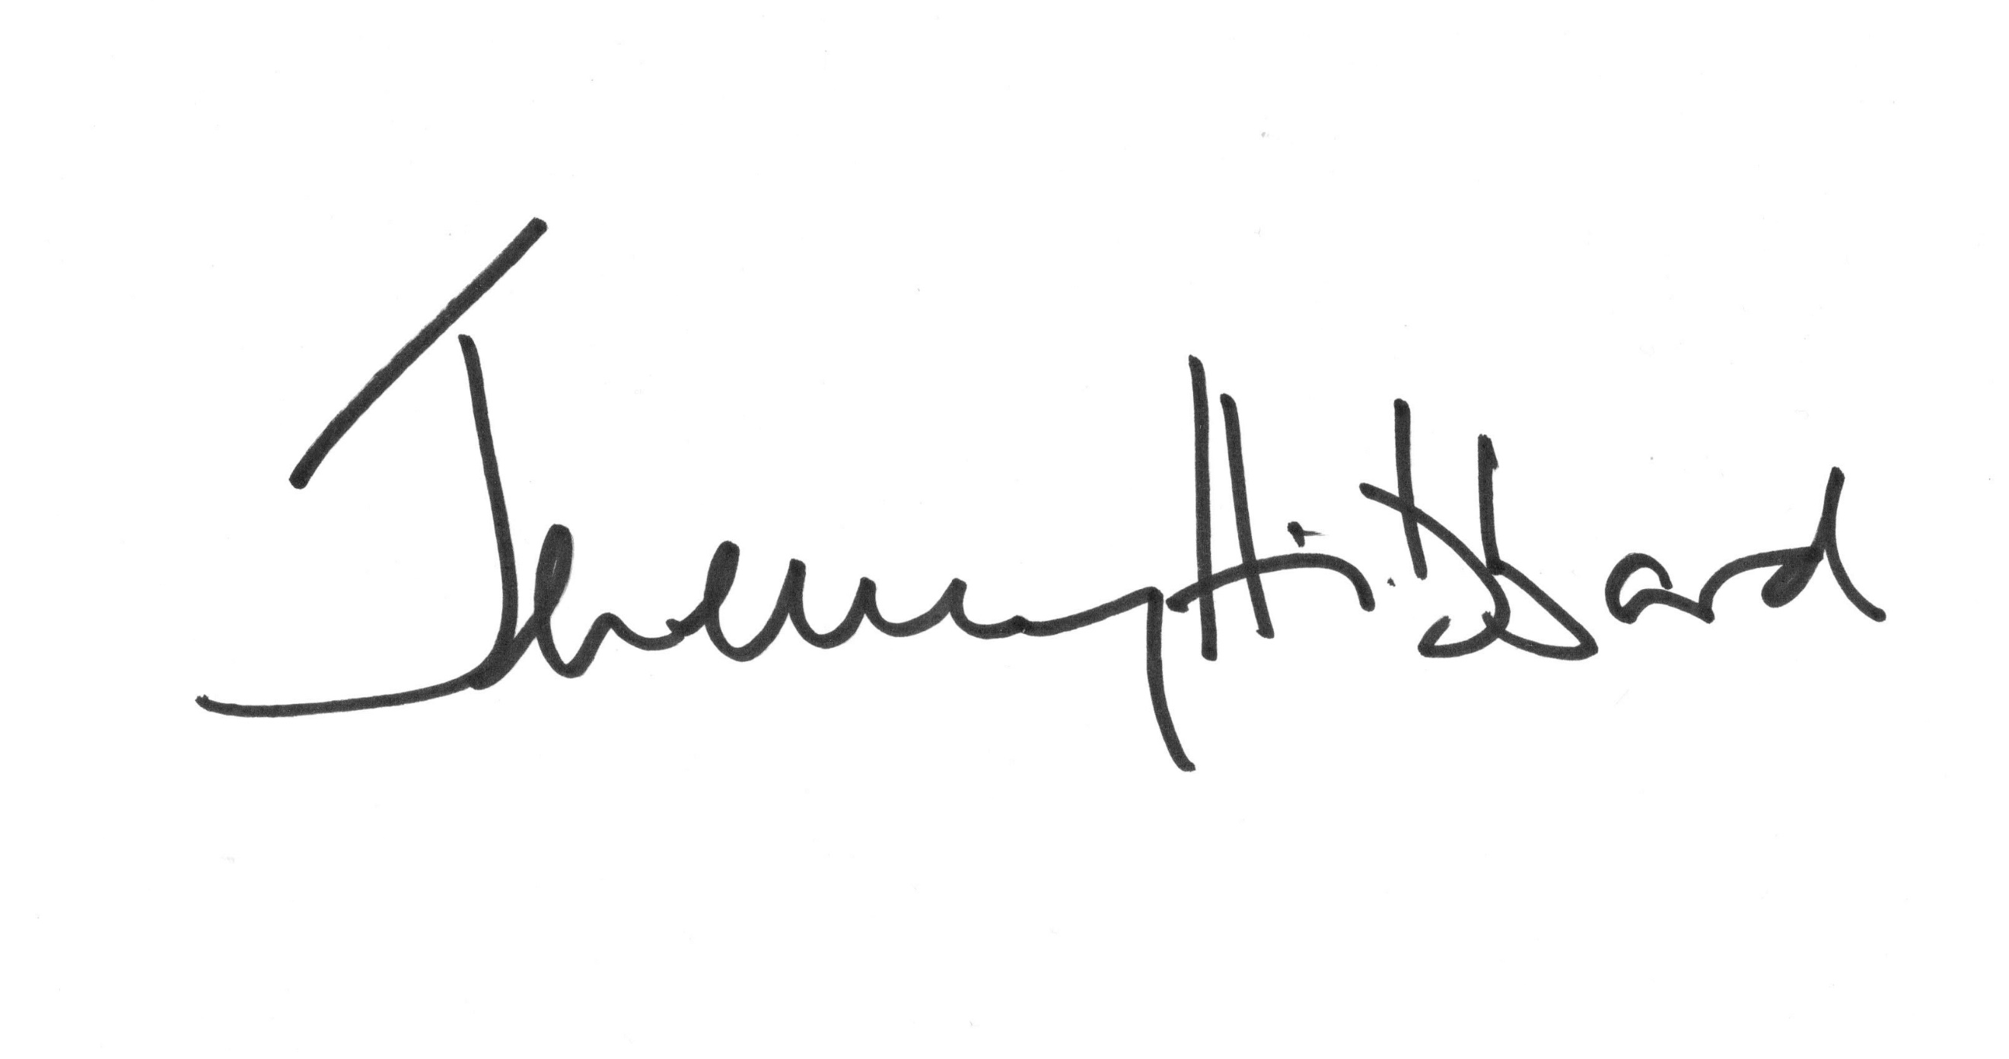
30.3.2022

